User Guide

Sai Krishna Thokala

119455081

sthokala

# Index Page

Index Page of the PhotoWebApp.

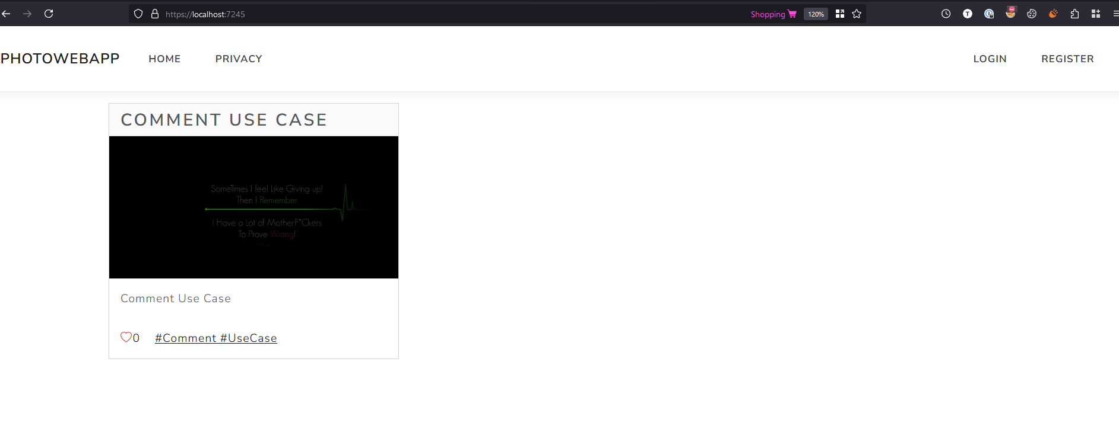

# Upload Photo Use Case

Login as Content Creator. Click Upload Photos.

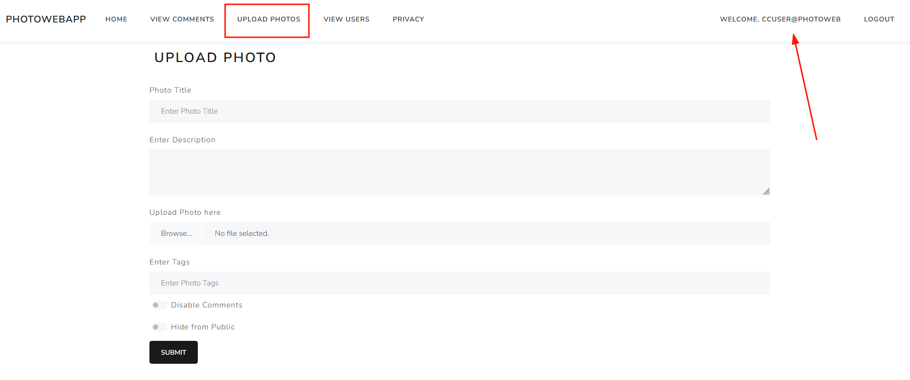

Fill the required details and upload the picture along with the tag included. If required to hide or disable comments, select one of them and click submit to upload the picture.

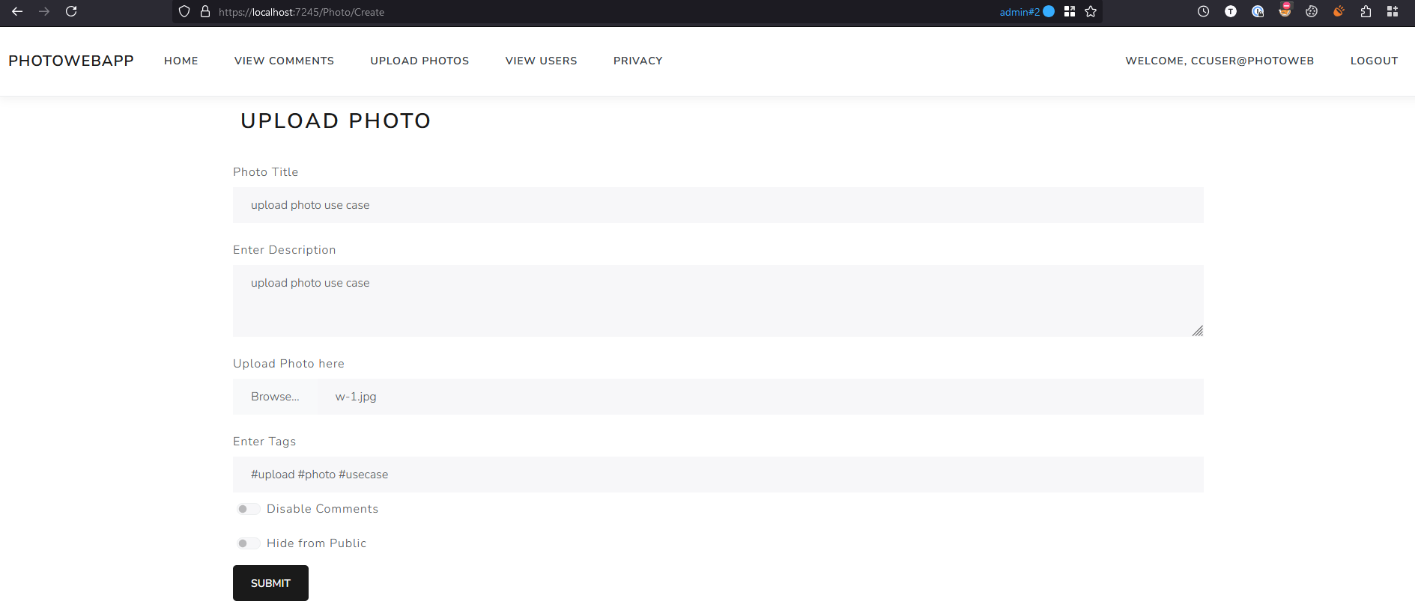

The below picture highlights the successfully uploaded photo as a content creator user.

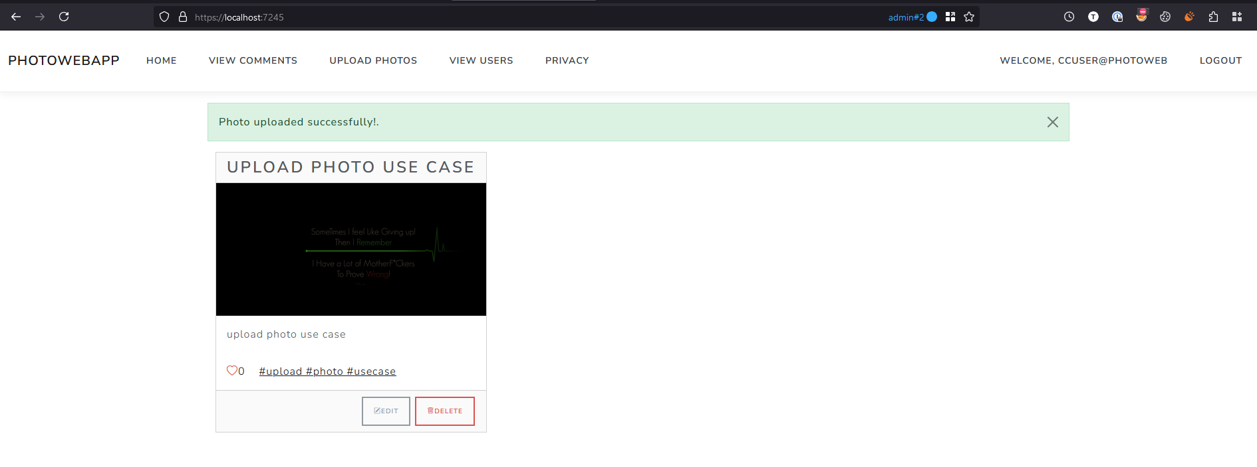

# Delete Users Use Case

Login as admin and click View Users as highlighted in the below picture.

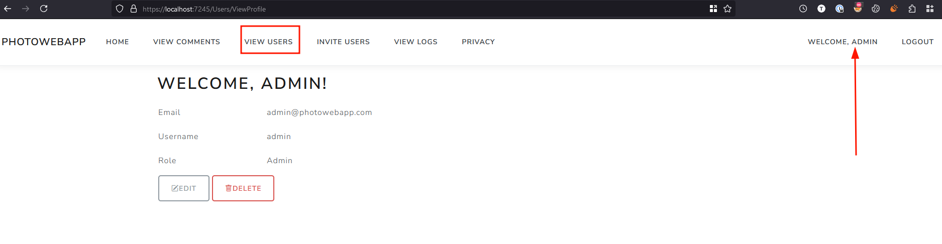

Click Edit button to update the view the edit page of the user.

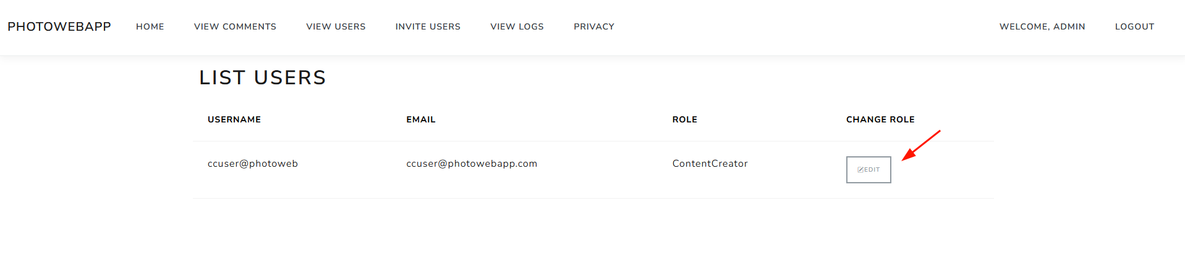

Click Delete button to delete the user.

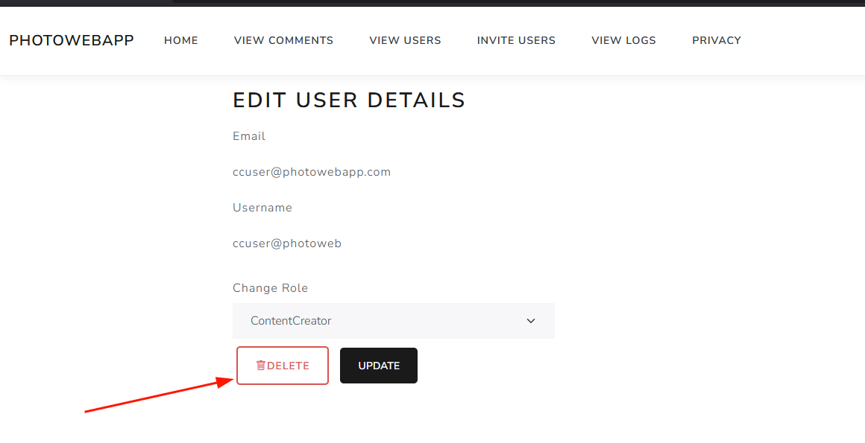

User deleted successfully with a message shown as successful.

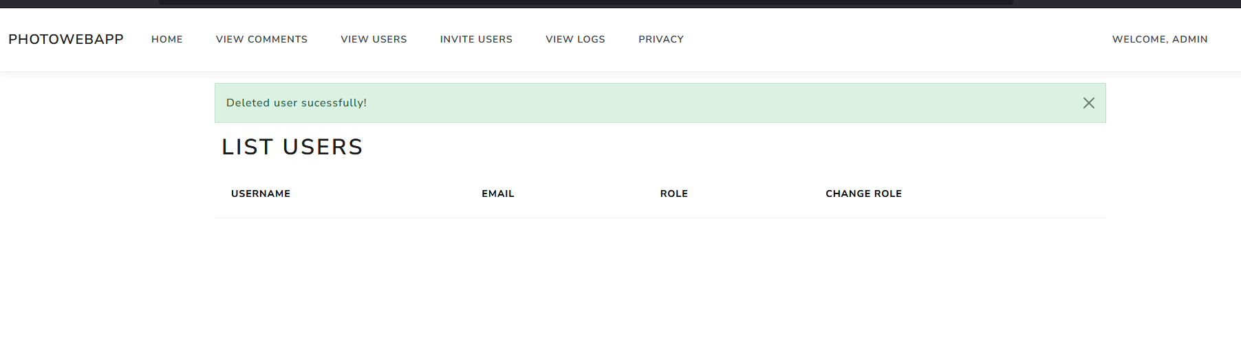

# Comment on Photo Use Case

Navigate to the PhotoWebApp index page and click on the photo.

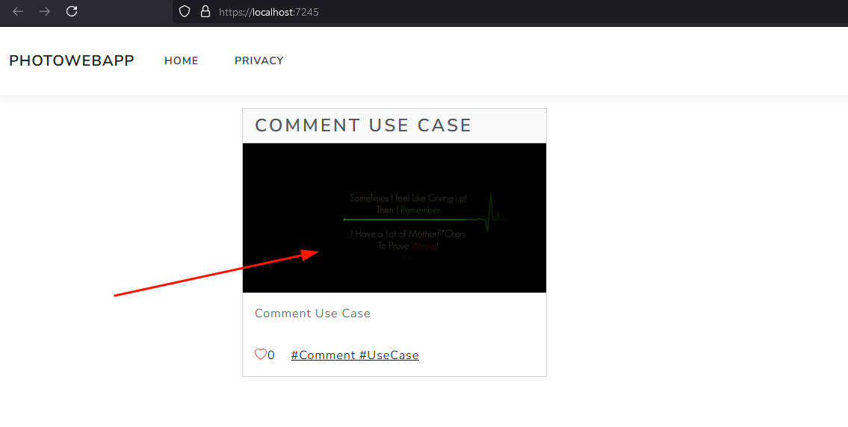

Insert the comment and click “Add Comment” button to post the comment.

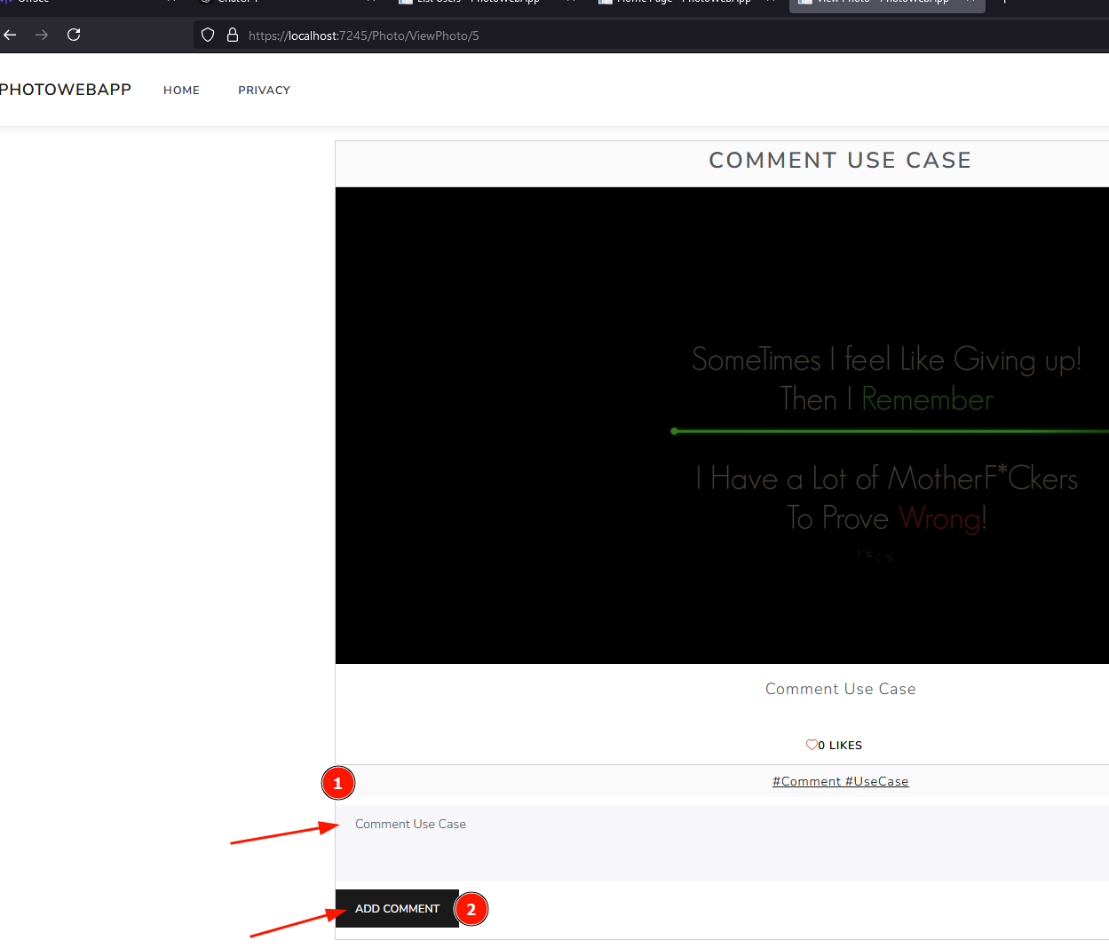

The below figure highlights the comment posted successfully.

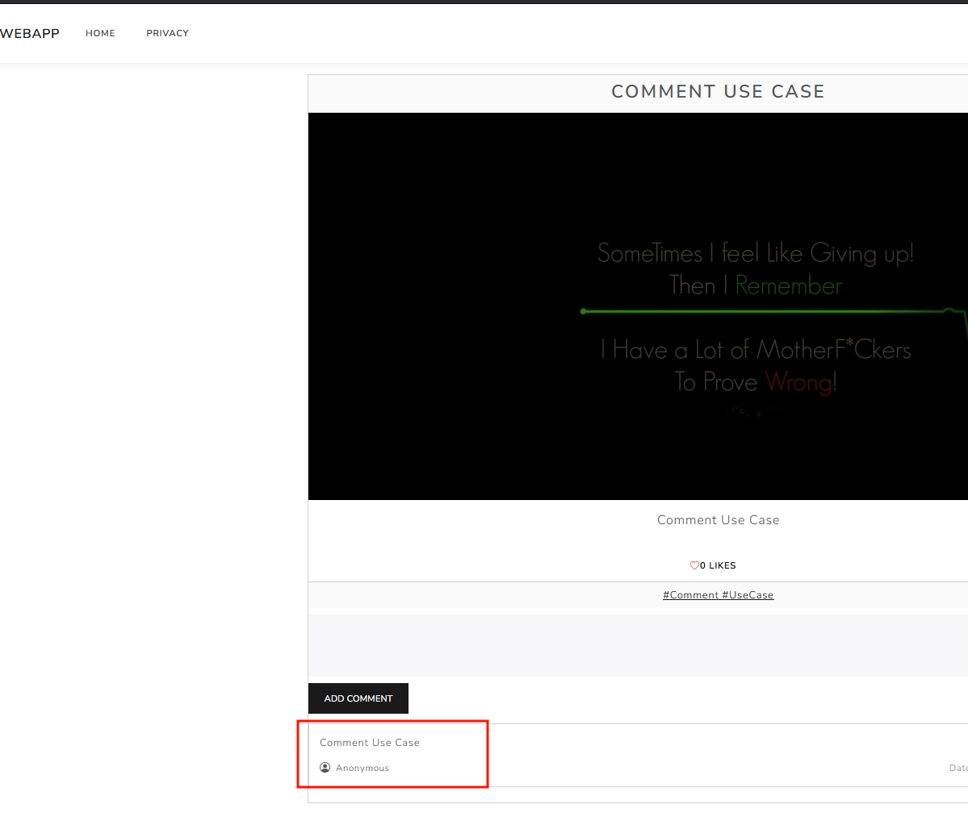

# View Logs Use Case

Login as Admin, Click “View Logs”.

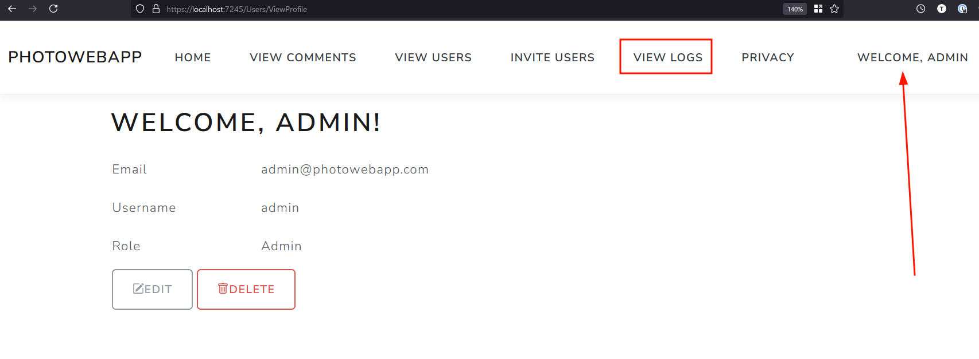

Observe the logs shown in the below figure.

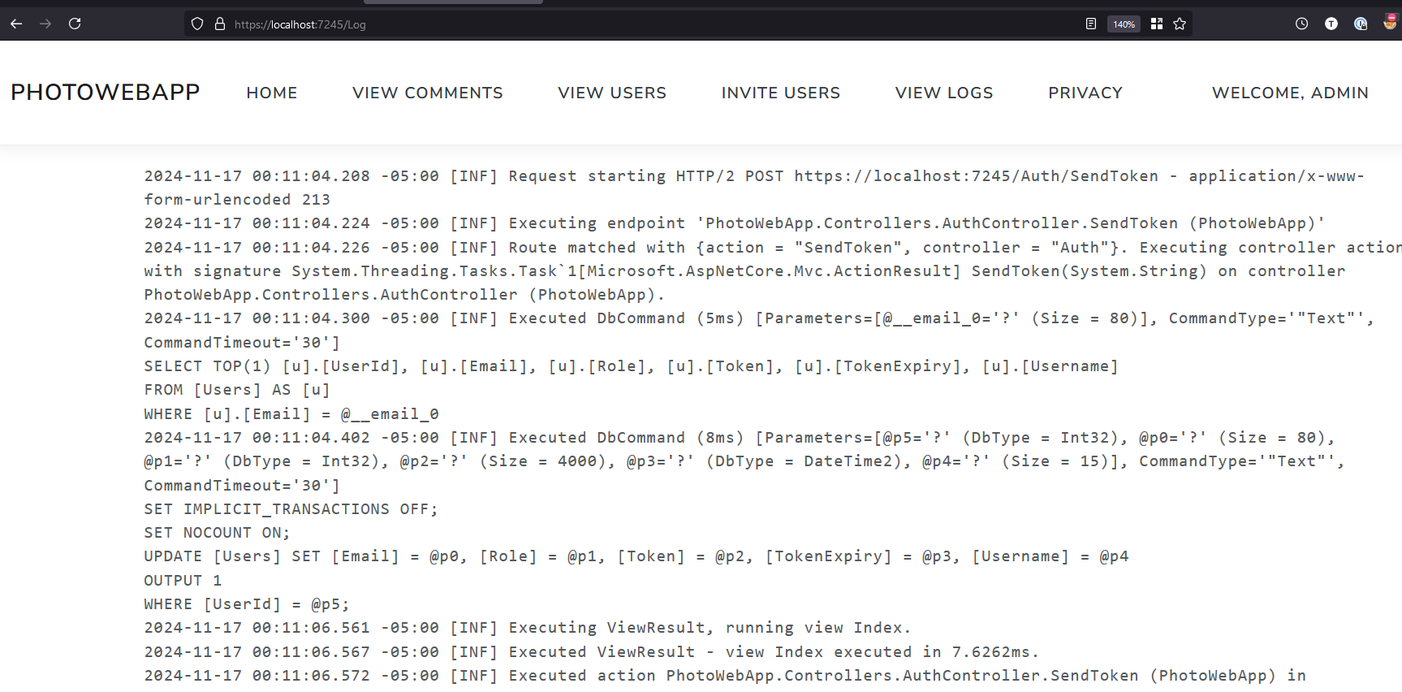

# Invite Users Use Case

Login as Admin and Click invite users.

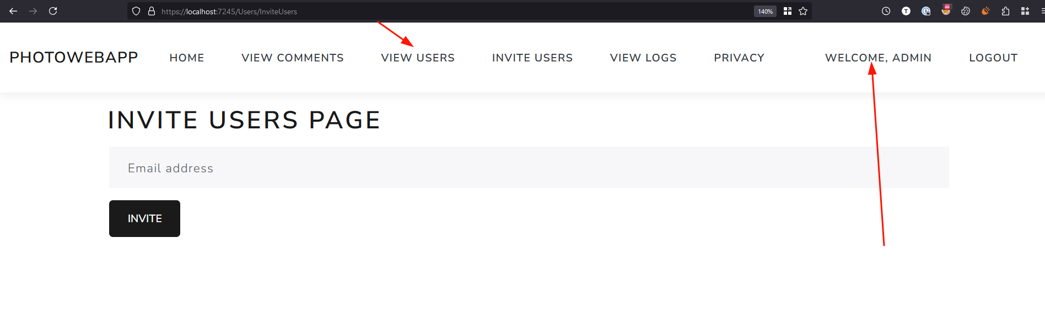

Enter the user email and click Invite button.

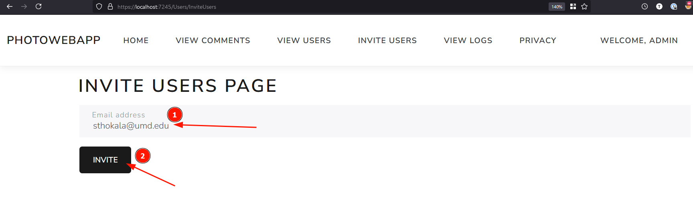

Observe the user is invited to join the PhotoWebApp successfully.

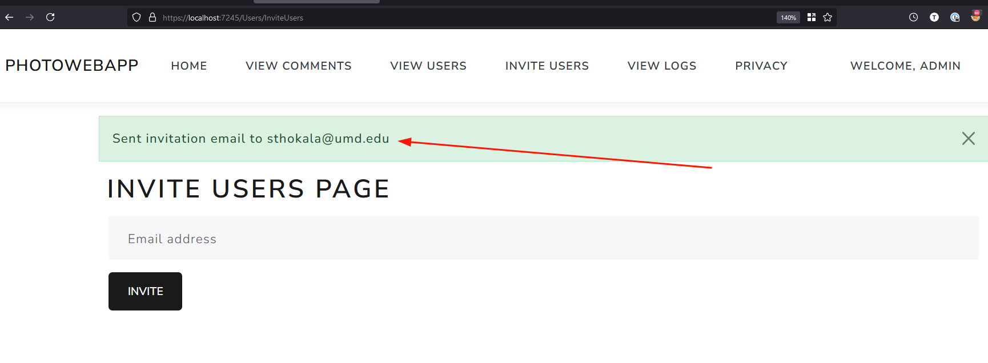

# List Comments Use Case

Login as Admin, click “View Comments”.

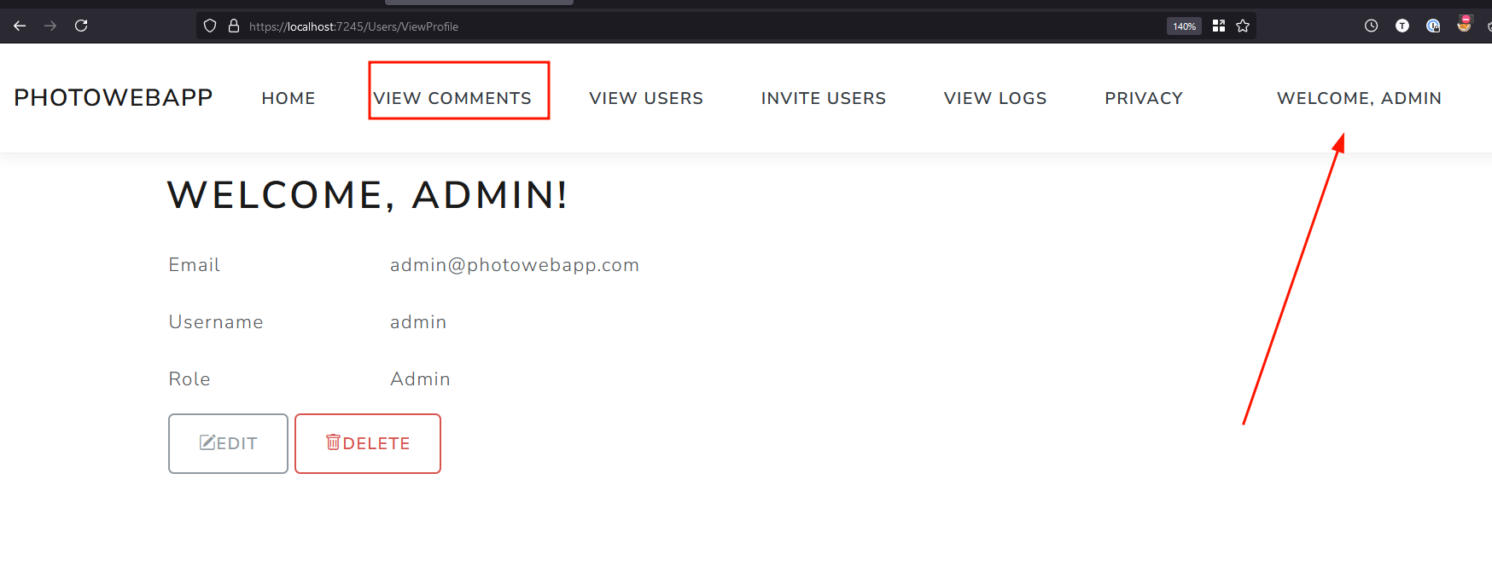

Observe the list of Comments posted by several users.

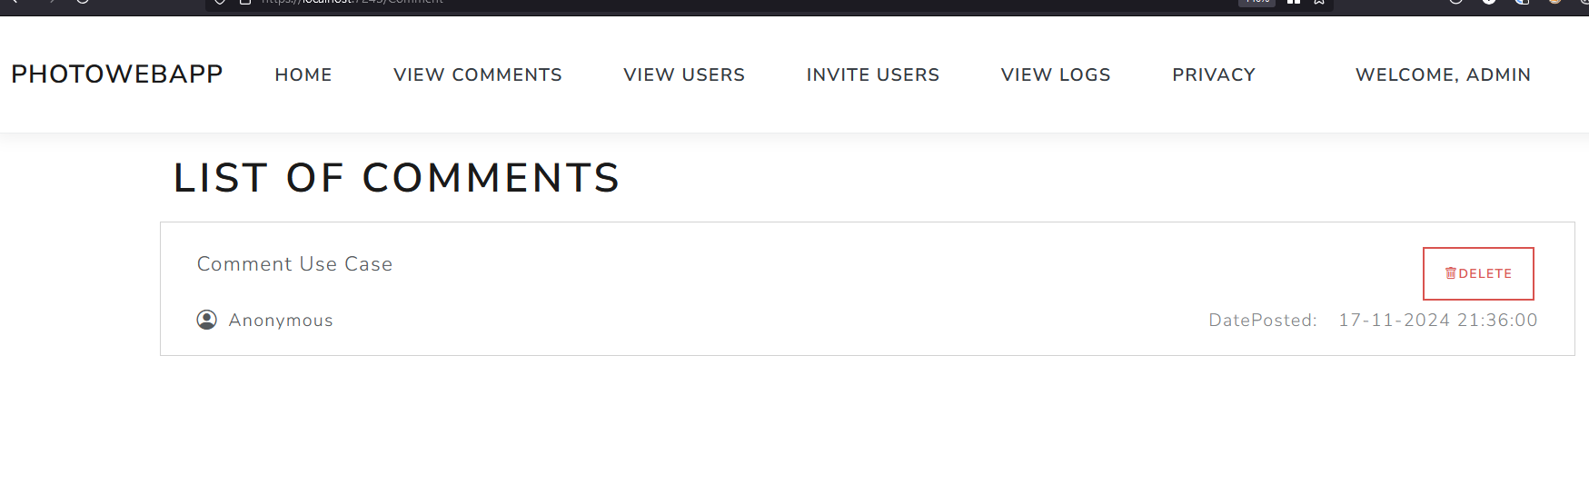

# List Users Use Case

Login as Admin, Click “View Users”.

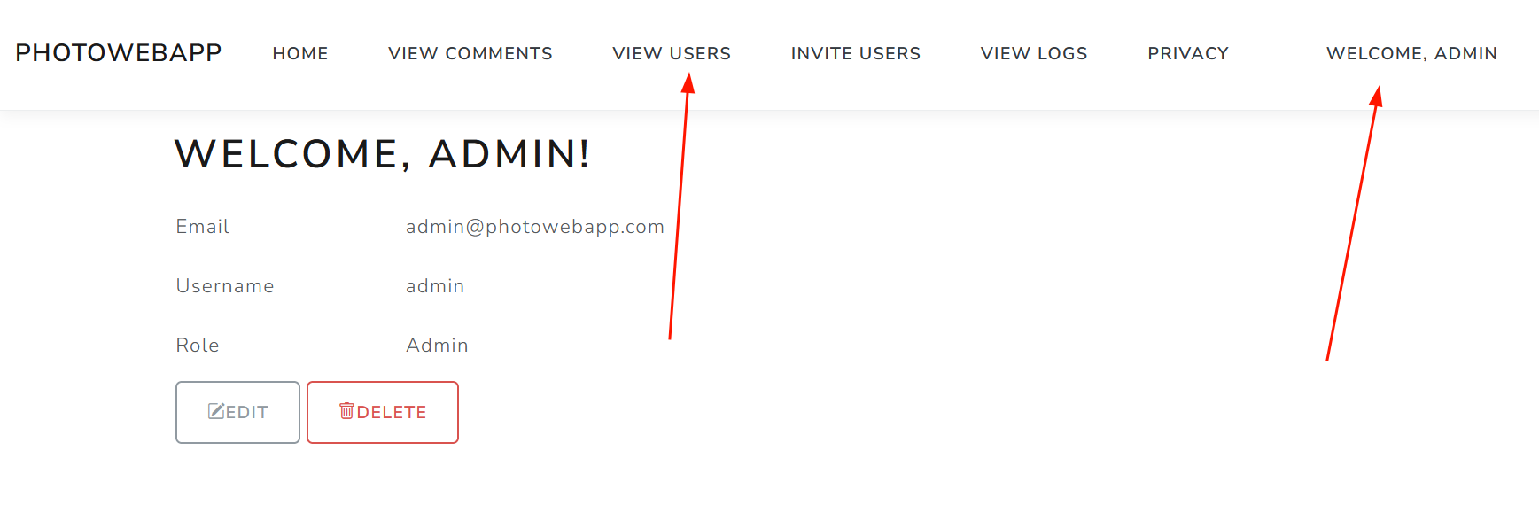

Observe the list of users in the Photo web app.

